**Project – Tool Rack FEA**

Name: Raphael Obu | Completion Date: 12/20/2020

**SUMMARY**

**Overview;**

Using provided product specifications (figure 1) and information from the manufacturer website I drew up a model of the tool rack in question in SolidWorks. (figure 2) To this model I assigned the material cast stainless steel. I then proceeded to convert he model into a mesh and assigned appropriate loadings where necessary as well as applying any necessary assumptions. Running the test demonstrated that the tool rack is more than capable of handling the manufacturer specified loading (figure 3) it should be noted that actual flexion is next to none. (figure 4)

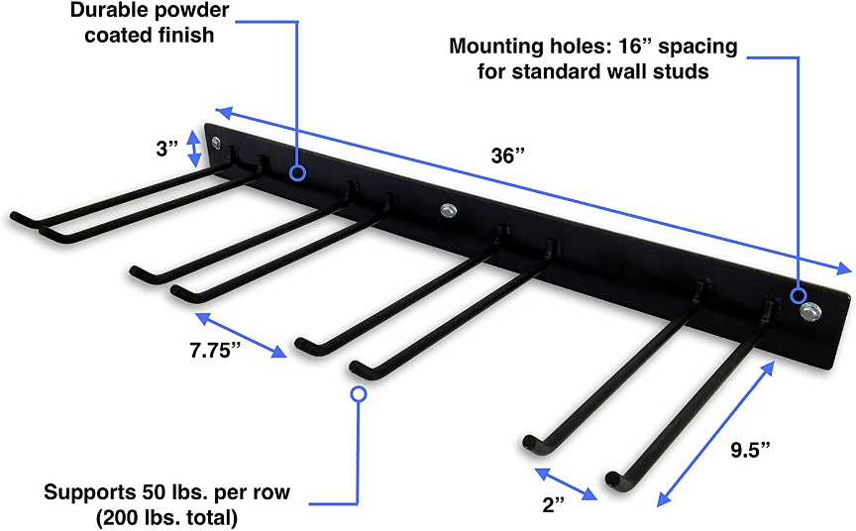**Figures;**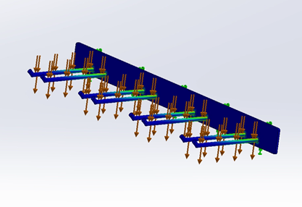

*Figure 2*

*Figure 4*

*Figure 3*

*Figure 1*